**This submission is original work and no part is plagiarized** (signed) Gaurav Pahwa

(Date)01/09/2021



**MECHANICAL ENGINEERING DEPARTMENT**

**Thapar Institute of Engineering and Technology, Patiala**

**Assignment - 4.**

**Design against failure under Dynamic actions**

***UTA016 Engineering Design Project-I***



**Assignment - 4.**

**Structural Engineering Component**

**Design against failure under** *dynamic* **actions**

Complete the following **individually, copying will be dealt with severely.**

**Instructions:**

1. Data to be used for excel spreadsheets graphs to be created for Q2 and Q3 is (will be provided by the respective lab instructors):

|  |  |  |
| --- | --- | --- |
| **Mass (kg)** | **Weight (N)** | **Height Failure (m)** |
|  |  |  |
|  |  |  |
|  |  |  |
|  |  |  |
|  |  |  |

1. **Excel spreadsheets graphs to be created for Q1 and Q2 will evaluated by end of tutorial class**. Remaining questions is to be submitted before next tutorial class (if it is a holiday, then as instructed).

Despite this list, try and enjoy the assignment and try to think around the subject as much as possible and take from it any tips that you might use with your own Catapult.

**When you have built your own mangonel, with your own choice of rotating arm, L2 part (i.e. spoon: material, diameter and length) and having measured the rotational velocity on impact using the electronic component of this project, then the procedures in Assignments 3 and 4 should allow you to make a reasonable prediction as to whether your chosen arm is likely to fail statically when fully loaded or dynamically when the missile is released. It would clearly be desirable to avoid an unexpected structural failure of any part during the competition!**

**Marking Scheme: Assignment 3 (5 Marks)**

1. **Evaluation at end of Tutorial: 2.5**
2. **Evaluation from printout submission:2.5**
3. A dowel of 0.006 m diameter (d), a beam span of 0.3 m, fails at a static failure load of 47 N. Calculate the static failure stress in Excel sheet.

|  |  |  |  |  |  |  |
| --- | --- | --- | --- | --- | --- | --- |
| **Measured** | | | **Calculated** | | | **Actual strength** |
| Span | Dia | Failure Force | M=PL/4 | y=d/2 | I=d^4/64 | y*M/I |
| L mm | d mm | P N | Nmm | mm | mm^4 | MPa(N/mm^2) |
|  |  |  |  |  |  |  |

1. (a) A series of dynamic tests were performed where weights of different magnitude were dropped onto the dowel span from different heights. The following table was produced;

|  |  |  |  |
| --- | --- | --- | --- |
| **Mass (kg)** | **Weight (N)** | **Height Failure (m)** | **Strike Velocity m/s** |
|  |  |  |  |
|  |  |  |  |
|  |  |  |  |
|  |  |  |  |
|  |  |  |  |

Insert a plot of weight against drop height to failure for the impact experiment.

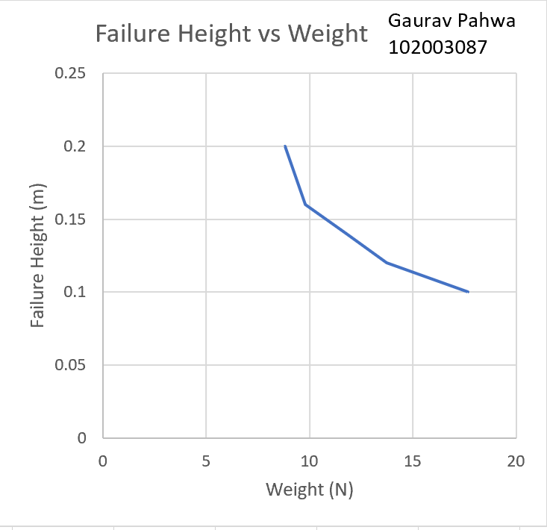

**(Table and Plot Evaluated at the end of the Tutorial class)**

(b) Comment on the shape of the plot and the magnitude of the values to failure when compared to the static failure load.

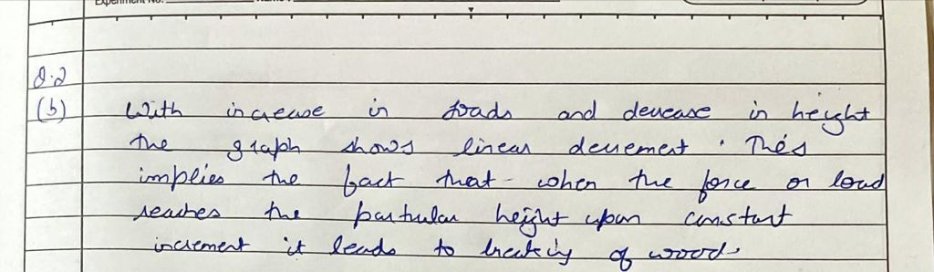

1. (a) From the tabulated the theoretical velocity on impact for the masses dropped from their respective heights from Q2 produce a plot.

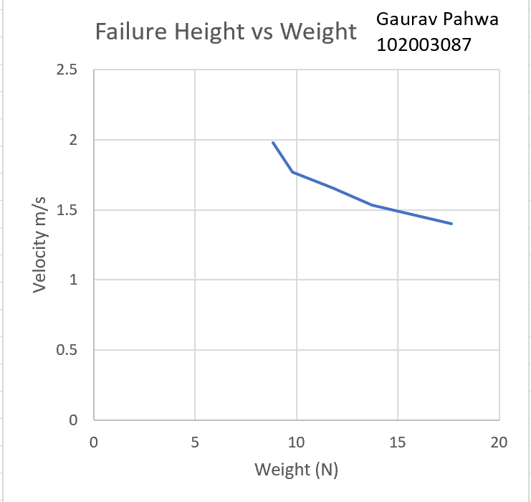

(b) Comment on this plot in comparison with the plot in Q2 above.

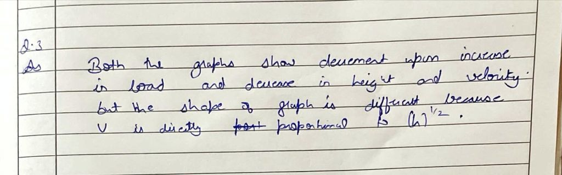

1. Using *Scenario 4: Case 1* from the lecture 3 and 4 supplementary notes, assuming a Dynamic Magnification Factor of 2, calculate the approximate maximum dynamic force that might be applied to the beam of Q1 inducing a stress equal to the static failure stress.

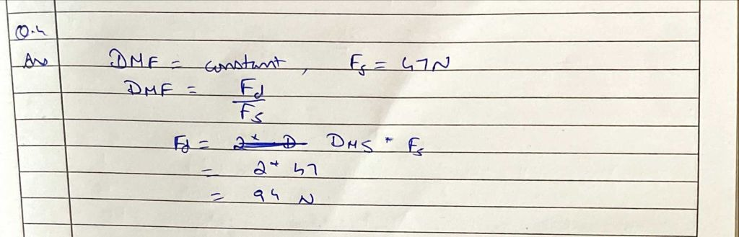

1. Using *Scenario 4: Case 2* in the lecture 3 and 4 supplementary notes, calculate the mass density, , (in units of kg/m3) of the timber dowel beam, the mass per unit length, **m**., (in kg/m) and the load per unit length,  (in N/m). The mass of the dowel was measured to be m=4.7g, 6mm diameter and the total length equal to L=0.3m

|  |
| --- |
|  |

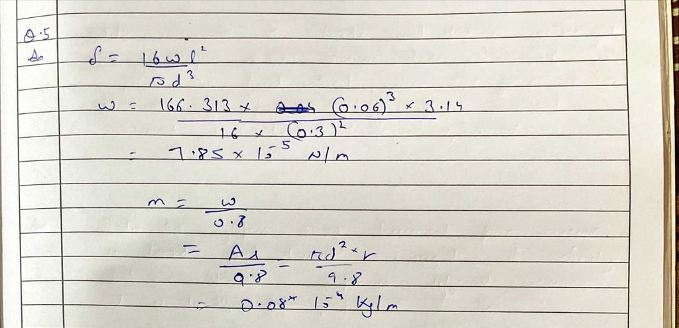

1. Using this value for **m**, and selecting an overhang for the arm of 0.2m (see Figure 3(b) in the lecture notes and slide 7 of lecture), calculate the theoretical deflection of this cantilever of length L2,6 mm diameter, under a static point load equivalent to its own weight when in fully locked state of the Mangonel arm. The value of the Young’s modulus of elasticity, E, can be assumed from the lecture notes.

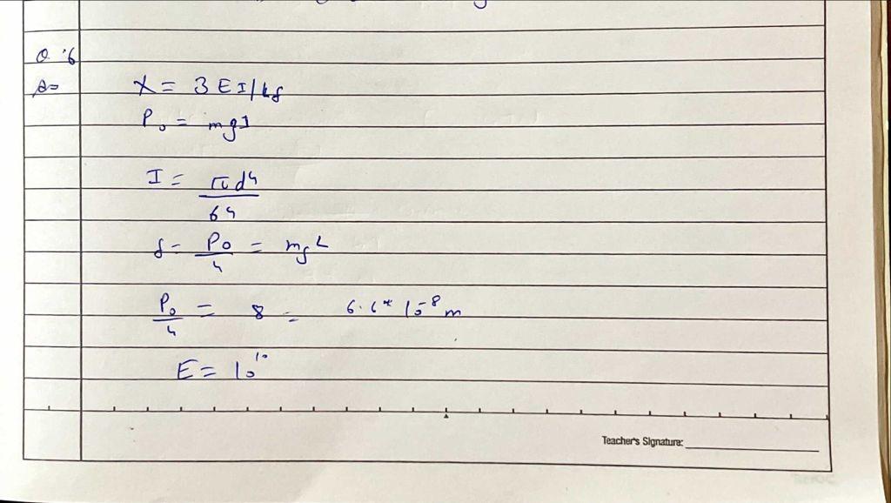

1. Due to the dynamic effect of a rotating cantilever, assumed equivalent to a drop height of h, calculate the Dynamic Magnification Factor for a variety of realistic impact velocities, using equation (4) in the lecture supplementary notes. You should use here the impact velocities of Q2.

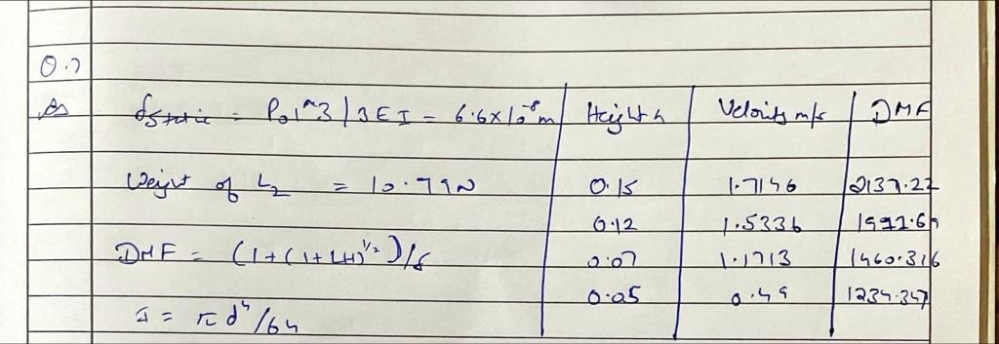

1. Take the velocity corresponding to the drop height of 0.25m (giving rise to a corresponding DMF) and check that this velocity on impact will not cause the cantilever of L2=0.2m to fail, taking failure stress from Q1, remembering that the dynamic stress can be approximated to dynamic = static x DMF, where staticis from last equation in lecture notes.

|  |
| --- |
|  |

